Batch: B2 Roll No.: 1611103
Experiment No. 8
Grade: AA / AB / BB / BC / CC / CD /DD

Title: Implementation of menu driven program Insertion, Selection sorting methods.

Objective:
To understand different sorting algorithm

Expected Outcome of Experiment:

CO | Outcome
3 | Demonstrate different sorting and searching methods

Books/ Journals/ Websites referred:

- Data Structures A Psedocode Approach with C, Richard F. Gilberg & Behrouz
- Forouzan, second edition, CENGAGE learning.
- C & Data Structures By O. G. Kakde.
- Data Structure Using C By ISRD Group.
- Data Structures using C, Reema Thareja, Oxford University Press.
- Introduction to Data Structure and its Applications Jean-Paul Tremblay, P.G.
Sorenson.

Related Theory: -
SELECTION SORT:
The selection sort algorithm sorts an array by repeatedly finding the minimum element (considering ascending order) from unsorted part and putting it at the beginning. The algorithm maintains two sub arrays in a given array.
1) The sub array which is already sorted.
2) Remaining sub array which is unsorted.
In every iteration of selection sort, the minimum element (considering ascending order) from the unsorted sub array is picked and moved to the sorted sub array.
Following example explains the above steps:
arr[] = 64 25 12 22 11

Find the minimum element in arr[0...4] and place it at beginning
11 25 12 22 64

Find the minimum element in arr[1...4] and place it at beginning of arr[1...4]
11 12 25 22 64

Find the minimum element in arr[2...4] and place it at beginning of arr[2...4]
11 12 22 25 64

Find the minimum element in arr[3...4] and place it at beginning of arr[3...4]
11 12 22 25 64

INSERTION SORT:
Insertion sort is a simple sorting algorithm that works the way we sort playing cards in our hands.
Example:
12, 11, 13, 5, 6
Let us loop for i = 1 (second element of the array) to 5 (Size of input array)
i = 1. Since 11 is smaller than 12, move 12 and insert 11 before 12
11, 12, 13, 5, 6
i = 2. 13 will remain at its position as all elements in A[0..I-1] are smaller than 13
11, 12, 13, 5, 6
i = 3. 5 will move to the beginning and all other elements from 11 to 13 will move one position ahead of their current position.
5, 11, 12, 13, 6
i = 4. 6 will move to position after 5, and elements from 11 to 13 will move one position ahead of their current position.
5, 6, 11, 12, 13

CODE:
#include<iostream.h>
#include<conio.h>
#include<stdlib.h>

void SelectSort(int a[],int n)
{
int i = 0,j=0,minindx,temp;
for(i=0;i<n-1;i++)
{
minindx = i;
for(j=i+1;j<n;j++)
if(a[j]<a[minindx])
minindx = j;
temp = a[i];
a[i] = a[minindx];
a[minindx] = temp;
cout<<"After loop no. "<<i+1<<endl;
for(int k = 0;k<n;k++)
cout<<a[k]<<" ";
cout<<endl;
}
}

void InsertionSort(int a[],int n)
{
if(n <= 1)
return;
InsertionSort(a,n-1);
int mini = a[n-1],j = n-2;
while(j>=0 && a[j] > mini)
{
a[j+1] = a[j];
j--;
}
a[j+1] = mini;
cout<<"After operation no. "<<n-1<<" the sorted array is : \n";
for(int k =0;k<n;k++)
cout<<a[k]<<" ";
cout<<endl;
}

int main()
{
clrscr();
int len;
cout<<"Enter the lenght of array to be sorted : ";
cin>>len;
int array[180];
cout<<"Enter the elements of array to be sorted : ";
for(int i=0;i<len;i++)
cin>>array[i];
int option;
cout<<"Enter sorting algo : \n";
cout<<"1.Selection Sort.\n2.Insertion Sort.\n";
cin>>option;
switch(option)
{
case 1:SelectSort(array,len);break;
case 2:InsertionSort(array,len);break;
default : cout<<"Fatal error in input\nTerminating program....\n";getch();exit(0);
}
cout<<"\nAfter sorting......\n";
for(i = 0;i<len;i++)
cout<<array[i]<<" ";
getch();
return 0;
}
OUTPUT:

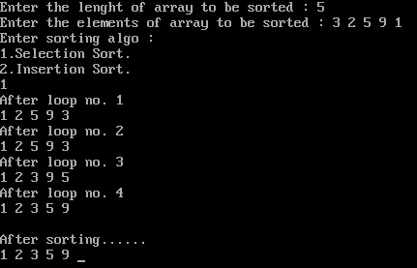
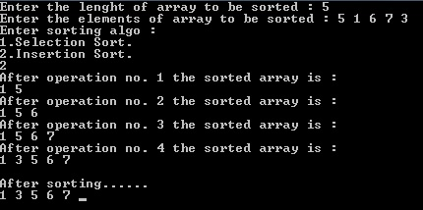
Implementation Details:
- Enlist all the Steps followed and various options explored
Ans. The program first takes the length of array and then the array as input. After that the user is given choice between sorting algorithms. The selection algorithm/sorting (as explained above) is performed using two nested for loops and the insertion sorting is performed using recursion. In both the functions after every single traversal/sorting of elements the new array is printed.
- Explain your program logic, classes and methods used.
Ans. SelectionSort(int a[], int n):
It perform the selection sort algorithm without recursion and then prints the updated array after every successful swapping of the elements.
InsertionSort(int a[], int n):
It performs insertion sort algorithm using recursion. It recurses until the last 2 elements are not left and then sorts them and this is now our sorted array on which further operations are performed according to algorithm. It prints every time the sorted array so obtained.

- Explain the Importance of the approach followed by you.
Ans. In my approach the code displays every updation/sorting operation performed by the respective algorithms. It also has a choice to select the sorting algorithm so we can compare for the same input of elements which sorting algorithm requires more no. of steps and which is more time consuming.

Conclusion:-
Conclusion: Thus both insertion and selection sort were successfully implemented.

Date: Signature of faculty in-charge

